Table of Contents

Abstract 3

1 Introduction 4

2 Specification 5

2.1 System Overview 5

2.2 Software 7

2.2.1 Front-end Software 7

2.2.2 Back-end Software 8

2.3 Hardware 10

2.3.1 Tag 10

2.3.2 Detector 12

2.3.3 Proxy 13

2.3.4 Parts Selection 14

3 Test Plan 14

3.1 Unit Tests 14

3.2 Hardware 14

3.2.1 Power supply unit 14

3.2.2 Tag 15

3.2.3 Detector 16

3.2.4 Proxy 17

3.3 Software 17

3.3.1 Controller 17

3.3.2 Web App 18

3.3.3 Database 19

3.4 Integration Tests 19

3.4.1 Tag and Detector’s Functionality 19

3.4.2 RF network and Proxy Communication 20

3.4.3 Locating with Multiple Detectors 20

3.4.4 Fully-integrated System 21

3.5 Acceptance Tests 22

3.5.1 Tag’s Size 22

3.5.2 Power 22

3.5.3 Accuracy 23

3.6 Final Results 25

3.6.1 Device dimensions 25

3.6.2 Power consumption 25

3.6.3 Accuracy 25

4 Discussions 26

5 Conclusions 26

5.1 What we learned 27

5.2 Good Decisions 27

5.3 Bad Decisions 27

5.4 Meeting our Expectations 27

5.5 Meeting our Sponsors Expectations 27

5.6 Group Dynamics 27

6 Appendices 28

6.1 Installation 28

6.1.1 Detector Deployment 28

6.1.2 Tag Deployment 28

6.1.3 Controller Setup 28

6.1.4 Proxy Setup 28

6.2 Maintenance 28

6.2.1 Replacing Batteries 28

6.2.2 Programming Firmware 28

6.2.3 Software Maintenance 29

6.2.4 Source codes 29

6.3 User Guide 29

6.3.1 Web-based application 29

6.3.2 Controller application 36

6.4 Hardware Design Specification 40

6.4.1 Detectors 40

6.4.2 Asset Tags 45

6.4.3 RFM12B Breakout board 49

6.5 Software Design Specification 51

6.6 Useful Links 51

7 References 51

# Abstract

TIU tracking system is a capstone project conducted by Portland State University students and sponsored by Intel Corp. The system will be used to track locations of Test Interface Units (TIUs) in the Intel Validation Lab.

In this paper, we propose a general architecture for the tracking system. The main goal of the architecture aims to achieve a low-cost, yet effective tracking system. The infrastructure of the tracking system is built upon RF transceivers which communicate wirelessly in a mesh network. The asset tags will be attached to tracked devices (TIUs). These asset tags will broadcast messages to detectors. Messages that contain received signal strength indication (RSSI) values will be routed though the mesh network to a server. The server will analyze the received data, calculate the locations, and store them in the database. A web application will then be able to access the database and display location information in an interactive 2D map.

The primary figures of merit that were used in the decision making process include accuracy, power consumption, size, and cost. The last administrative idiom this paper conveys is a road map which will guide our team to the final objective. The means by which this is accomplished is through a tentative schedule, timeline, a list of milestones and expected deliverables.

# Introduction

Location aware computing has a bright future in the fields of personal navigation, personal security, prompt healthcare and entertainment. Furthermore, information on the physical location of mobile nodes can greatly help in urban search and rescue missions, as well as enable geographical routing in ad hoc multi-hop networks. The determination of physical location is sometimes referred to as location estimation, location identification, localization, and positioning or geolocation identification.

Chip manufacturers today face dramatic upheaval across the industry. Companies (such as Intel) need to find ways to remain profitable at a time when economic turbulence is curtailing consumer buying power. In the midst of these changes, plant managers must find a way to address the problem of improving processes while becoming more cost-effective.

As part of this effort, Intel wants to automate tracking of the Test Interface Units (TIU) at different locations of the Intel lab, with the intention of wirelessly locating a TIU’s physical position at all times. Given the size and complexity of Intel validation lab, locating Test Interface Units (TIU) can be a tedious task since the test equipments have to be broken down to identify the TIU it is using. Therefore, an effective TIU tracking system rises as an urgent need.

By tracking location of the TIU’s physical position in the lab, Intel can minimize downtime and decrease labor costs caused by the size and complexity of Intel validation lab. This solution enables:

* Increased equipment utilization
* Decreased loss and theft
* Reduced costs
* Faster production
* Avoid time wasted on manual searches and inventory checks.

This capstone project will be a prototype system that can wirelessly track the location of at least 10 TIUs in an indoor environment. The duration of the project will last 6 months.

# Specification

## System Overview

Figure 3-1 shows a network of detectors that are geometrically located in a grid array. The density of the grid array will primarily be a ratio of accuracy and cost. For the scope of this project, the reasonable number of detectors would be from five to seven. The location of the proxy must be within range of at least one detector.

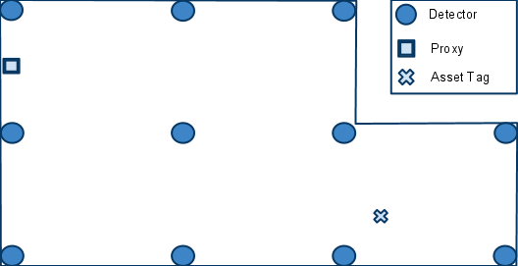

Figure : A hypothetical room with detectors positioned in a grid array. Also shown is an arbitrarily placed proxy.

There are two distinct networks which compose this system: the front-end network, which includes all the physical nodes, and the back-end network, which includes all the logical nodes (Figure 3-2). The proxy is the gateway between the two networks.

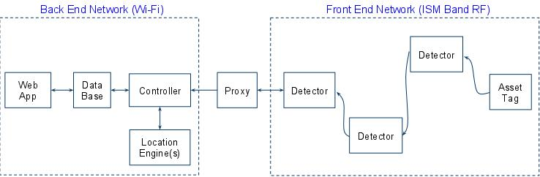

Figure : Front-end and back-end network topologies.

There are three important aspects to the communications that take place in the front-end network.

* Each asset tag will broadcast a message periodically. Neighboring detectors will detect the broadcast, and determine the RSSI of the broadcasting asset tag.
* When a detector determines the RSSI of a broadcasting asset tag, it must then transmit this data towards the proxy using a routing table. The routing table will be configured in such a way as to ensure the data moves in a direction that is physically towards the proxy.
* The locating application will periodically receive bursts of RSSI information from various detectors. Since it has no knowledge of how many detectors actually detected a broadcasting asset tag, it will wait a certain amount of time that assumes all the RSSI information from the various detectors has finished coming in.

Now we will further discuss some finer points of the second aspect. Figure 3-3 shows the paths taken as a result of an asset tag’s broadcasting. When an asset tag broadcasts, the nearest detectors are able to determine the corresponding RSSI values. The detectors that detected the asset tag broadcast are denoted by a connection with a green arrow. Each detector will have a routing table programmed into them. The routing table will contain information that steers the messages physically toward the proxy. In the example shown in Figure 3-3, the routes taken are in red. The blue dash paths are routes that exist but are not taken.

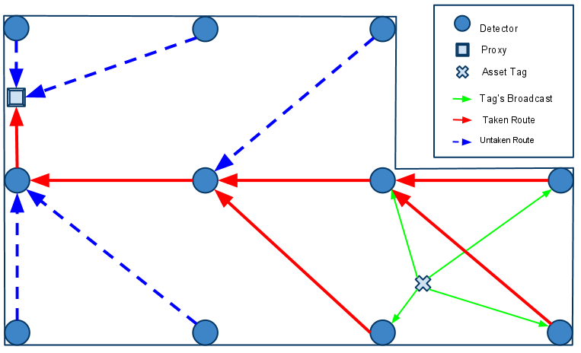

Figure : An example of the routing paths as a result of an asset tag’s broadcasting.

## Software

### Front-end Software

The front-end software consists of the firmware for the detectors, and the asset tags.

For a detector to determine the RSSI of an asset tag, the asset tag must broadcast a message. The message has eight fields, as shown in Figure xx. The way the fields are used depends on the origin of the message. There are two possible origins of a message. The first type of origin is an asset tag. A message can be identified as coming from an asset tag by examining the Detector ID, Source ID, and RSSI value fields. If all three fields contain the value zero, then the message originates from an asset tag. Otherwise, the message originates from a detector.

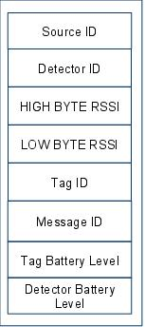

Figure : Message format.

When receiving a message whose DID is not zero, a detector will do four things:

1. Replace the Detector ID of the message with a Detector ID contained in its routing table
2. Replace the Source ID of the message with its own ID
3. Replace the RSSI value with that inferred from the reception of the asset tag broadcast
4. Rebroadcast the message

An example of this message passing sequence is show in Figure 5. **(Need modified)**

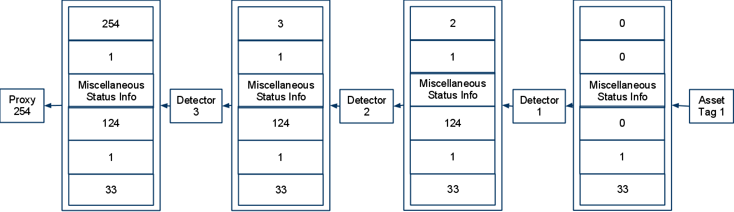

Figure : A example of a message originating from a asset tag, and being relayed to a proxy.

### Back-end Software

The back-end network, composed exclusively of logical nodes, will rely on normal internet communication. This allows applications to leverage TCP/IP and many APIs that have been built upon it. Also, we gain the advantage of being able to have standard inter-nodal communication regardless of if they exist on the same computer or not. This increases the scalability of the system.

The back-end software system consists of four components:

* SQL Database
* Web Application
* Controller
* Location Engine

#### SQL Database

The SQL database is a central component that provides a link among the web application, the controller, and the location engine. Specifically, the database stores the following data:

* Location update interval
* Geometry of the tracking area
* RSSI-distance model or RF fingerprinting
* Identifications and locations of the detectors
* Identifications, locations, and battery levels of the TIUs
* Mapping table between asset tags’ ID and TIUs’ ID

We agree on using SQL since it is a standard that is easy to use, secure and scalable.

#### Web application

The web application provides an interface for users to access the location information in the database. Its functionalities are:

* Display the locations and battery levels of all tracked TIUs on an interactive 2D map
* Allow users to search for a TIU via its ID. In case the ID is not complete or unique, the application will highlight the locations of all matched TIUs
* Allow users to view location history of the TIUs
* Alert users when a TIU is brought out of bounds or when it runs out of battery

The web application consists of two components: the client side and the server side. The client side will be implemented using modern web technologies such as HTML5, JavaScript, CSS3, and AJAX. The server side could be built upon one of the two most popular web server applications, i.e. Microsoft IIS and Apache.

#### Controller

The controller application is a GUI application that allows an administrator to manage the system. It allows the administrator to

* Modify the geometry of the tracking area
* Remap asset tags’ ID to TIUs’ ID
* Add or remove devices (detectors and asset tags)

The controller also receives RSSI data from the proxy, preprocesses them before feeding them into the location engine.

#### Location Engine

The location engine receives RSSI values from the controller and uses those values to calculate the locations of the asset tags. The derived locations will then be stored in the database.  
In case of using battery to power the asset tags, this application also receives battery level reports of the asset tags from the detectors and update the data in the database. This application should be written in a programming language that supports SQL database access and network communication.

The controller and the locating applications are discussed herein as two separate applications. However, they can definitely be combined into one single application.

Locating Algorithm

Fingerprint method based on Euclidean distance calculations

**(Dung)**

## Hardware

### Tag

An asset tag consists of two major parts:

* Microcontroller: ATMega328P – 32 TQFP
* RF transceiver: RFM12B-S2 Wireless Transceiver Module

Table : Tag Specifications

|  |  |
| --- | --- |
| **Specification** | **Description** |
| Microcontroller | ATMega328P – 32 TQFP |
| RF Transceiver | RFM12B-S2 Wireless Transceiver |
| Voltage regulator | XC6221 |
| Power supply | 6V Battery (two 3-V coin cells in holder) |
| Program Interface | ISP 6-pin header |
| Operating Frequency Band | ISM 433 MHz |
| Power Indicator | No |
| RF Indicator | No |
| PCB size |  |
| Microcontroller module | 25.4mm x 25.4mm |
| RF Transceiver | 20.3mm x 25.4mm |
| Outline Dimension |  |

Table : Electrical Characteristics

|  |  |  |  |  |
| --- | --- | --- | --- | --- |
| **Specification** | **Min** | **Typ** | **Max** | **Unit** |
| Power Supply | 3.3 | 6.0 | 6.0 | V |
| Transmit Current | 30mA | 30mA | 30mA | mA |
| Receive Current | N/A | N/A | N/A | N/A |
| Idle Current | 40µA | 40µA | 40µA | µA |
| Power-down Current | 99mA | 99mA | 99mA | mA |
| Power Dissipation | 30mA | 30mA | 30mA | mA |
| Operating Temperature | -25 |  | +85 | 0C |

The microcontroller controls the RF transceiver. The RF transceiver is responsible for communicating information to the system.



Figure : Board layout of the controller module on a tag



Figure : Board layout of the RF module on a tag

### Detector

A detector consists of two major parts:

* Microcontroller: ATMega328P – 28 DIP
* RF transceiver: RFM12B-S2 Wireless Transceiver

Table : Detector Specifications

|  |  |
| --- | --- |
| **Specification** | **Description** |
| Microcontroller | ATMega328P – 28 DIP |
| RF Transceiver | RFM12B-S2 Wireless Transceiver |
| Voltage regulator | MIC5205 150mA Low-Noise LDO Regulator |
| Power supply | 9V Battery |
| Program Interface | ISP 6-pin header |
| Operating Frequency Band | ISM 433 MHz |
| Power Indicator | Yes (regular red LED) |
| RF Indicator | Yes (green LED) |
| PCB size | 25.4mm x 88.9mm |
| Outline Dimension |  |

Table : Electrical Characteristics

|  |  |  |  |  |
| --- | --- | --- | --- | --- |
| **Specification** | **Min** | **Typ** | **Max** | **Unit** |
| Power Supply | 3.3 | 9.0 | 16.0 | V |
| Transmit Current | 30mA | 30mA | 30mA | mA |
| Receive Current | 30mA | 30mA | 30mA | mA |
| Idle Current | 40µA | 40µA | 40µA | µA |
| Power Dissipation | 99mA | 99mA | 99mA | mA |
| Operating Temperature | -25 |  | +85 | 0C |



Figure : Board layout of a detector

The microcontroller controls the RF transceiver. The RF transceiver is responsible for communicating information to the system.

### Proxy

The proxy consists of three major parts:

* Microcontroller unit
* RF transceiver unit: RFM12B-S2 Wireless Transceiver Module
* Wi-Fi transceiver: WiFly GSX Module

Table : Proxy Specifications

|  |  |
| --- | --- |
| **Specification** | **Description** |
| Microcontroller | ATMega328P – 28 DIP |
| RF Transceiver | RFM12B-S2 Wireless Transceiver |
| Voltage regulator | LM317 |
| Power supply | 6V Battery |
| Program Interface | USB |
| Operating Frequency Band |  |
| RF Transceiver | ISM 433 MHz |
| Wi-Fi Transceiver | 2.4 GHz Standard |
| Power Indicator | Yes |
| Transmission Indicator | Yes |
| Outline Dimension | Prototype on bread board |
|  |  |

Table : Electrical Characteristics

|  |  |  |  |  |
| --- | --- | --- | --- | --- |
| **Specification** | **Min** | **Typ** | **Max** | **Unit** |
| Power Supply | 3.3 | 6V | 6V | V |
| Transmit Current |  |  |  |  |
| Receive Current |  |  |  |  |
| Idle Current |  |  |  |  |
| Power-down Current |  |  |  |  |
| Power Dissipation |  |  |  |  |
| Operating Temperature | -25 |  | +85 | 0C |

The microcontroller is responsible for relay data between the two transceivers.

### Parts Selection

|  |  |  |  |
| --- | --- | --- | --- |
| D:\Study\Capstone Proj\Docs\Photos\09582-08.jpg | D:\Study\Capstone Proj\Docs\Photos\download.jpg | D:\Study\Capstone Proj\Docs\Photos\ATMegaDIP.jpg | D:\Study\Capstone Proj\Docs\Photos\328PQFP.jpg |
| **RFM12B-S2 Wireless Transceiver Module** | **WiFly GSX Breakout** | **ATMega328P – 28 DIP Pinout** | **ATMega32P – 32 TQFP Pinout** |

Refer to datasheets provided by manufacturers for more information (See **Useful Links** section in **Appendices**).

# Test Plan

## Unit Tests

## Hardware

### Power supply unit

|  |  |  |  |
| --- | --- | --- | --- |
| Test Writer: Lynh Pham | | | |
| Test Case Name | Power Supply Unit | Test ID #: | Pwr_01 |
| Description: | Measure output voltage of voltage regulator. Input voltage is supplied by power supply in capstone lab. Record output voltage versus input voltage values. | Type: | white box  black box |

|  |  |  |  |  |  |  |  |
| --- | --- | --- | --- | --- | --- | --- | --- |
| Tester Information | | | | | | | |
| Name of Tester: | | Lynh Pham | | Date: | | |  |
| Hardware Version: | | **Voltage regulator Mic5205** | | Time: | | |  |
| Setup: | | Connect voltage meter to jumper VCC output (JP_PWR) to measure output voltage | | | | | |
| Test | Input Voltage | Expected Output | Pass | | Fail | N/A | Comments |
| 1 | Check the red LED | Should be on with the connected jumper |  | |  |  |  |
| 2 | Connect 6V DC (4xAA batteries) to power jack | Output should be 3.3V+3% |  | |  |  |  |
| 3 | Connect 9V DC battery to power jack | Output should be 3.3V+3% |  | |  |  |  |
| 4 | Connect 9V adapter to power jack | Output should be 3.3V+3% |  | |  |  |  |
| Overall test result: | | |  | |  |  |  |

|  |  |  |  |  |  |  |  |
| --- | --- | --- | --- | --- | --- | --- | --- |
| Tester Information | | | | | | | |
| Name of Tester: | | Lynh Pham | | Date: | | |  |
| Hardware Version: | | **Voltage regulator XC6221** | | Time: | | |  |
| Setup: | | Connect voltage meter to jumper VCC output (JP_PWR) to measure output voltage | | | | | |
| Test | Input Voltage | Expected Output | Pass | | Fail | N/A | Comments |
| 1 | Check the red LED | Should be on with the connected jumper |  | |  |  |  |
| 2 | Connect 6V DC (4xAA batteries) to power jack | Output should be 3.3V+3% |  | |  |  |  |
| 3 | Connect 6V DC battery to power jack | Output should be 3.3V+3% |  | |  |  |  |
| Overall test result: | | |  | |  |  |  |

### Tag

|  |  |  |  |
| --- | --- | --- | --- |
| Test Writer: Lynh Pham | | | |
| Test Case Name | Asset Tag Electrical Testing | Test ID #: | Tag_01 |
| Description: | Checks the asset tag responding RSSI outputs. | Type: | white box  black box |

|  |  |  |  |  |  |  |  |
| --- | --- | --- | --- | --- | --- | --- | --- |
| Tester Information | | | | | | | |
| Name of Tester: | | Lynh Pham | | Date: | | |  |
| Hardware Version: | | Asset tag | | Time: | | |  |
| Setup: | | Remove the breakout board then connect the programmer cable to the SPI on the board. Power the testing board. Connect the base station to a PC by USB cable. | | | | | |
| Step | Action | Expected result | Pass | | Fail | N/A | Comments |
| 1 | Compile the final firmware version. | Arduino software should generate no warning/error |  | |  |  |  |
| 2 | Download firmware to MCU | AVR Studio should generate no error |  | |  |  |  |
| 3 | Turn off power |  |  | |  |  |  |
| 4 | Remove the cable from SPI |  |  | |  |  |  |
| 5 | Insert the breakout board into the tag |  |  | |  |  |  |
| 6 | Turn on power |  |  | |  |  |  |
| 7 | Open software controller | A new window should open |  | |  |  |  |
| 8 | Click Start | RSSI signal should be showed up on the window with Tag ID |  | |  |  |  |
| 9 | Repeat step 1-8 for other tags |  |  | |  |  |  |
| Overall test result: | | |  | |  |  |  |

### Detector

|  |  |  |  |
| --- | --- | --- | --- |
| Test Writer: Lynh Pham | | | |
| Test Case Name | Detector Electrical Testing | Test ID #: | Dec_01 |
| Description: | Checks the detector receiving RSSI from the asset tag. | Type: | white box  black box |

|  |  |  |  |  |  |  |  |
| --- | --- | --- | --- | --- | --- | --- | --- |
| Tester Information | | | | | | | |
| Name of Tester: | | Lynh Pham | | Date: | | |  |
| Hardware Version: | | Detector | | Time: | | |  |
| Setup: | | Connect the programmer cable to the SPI on the board. Power the testing board and an asset tag. Connect the base station to a PC by USB cable. | | | | | |
| Step | Action | Expected result | Pass | | Fail | N/A | Comments |
| 1 | Check the red LED | Should be on when turn the power switch on |  | |  |  |  |
| 2 | Compile the final firmware version. | Arduino software should generate no warning/error |  | |  |  |  |
| 3 | Download firmware to MCU | AVR Studio should generate no error |  | |  |  |  |
| 4 | Turn off power | The red LED should be off |  | |  |  |  |
| 5 | Remove the cable from SPI |  |  | |  |  |  |
| 6 | Turn on power | The red LED should be on |  | |  |  |  |
| 7 | Open software controller | A new window should open |  | |  |  |  |
| 8 | Check the green LED | Should be blinking with the connected jumper |  | |  |  |  |
| 9 | Click Start | RSSI signal should be showed up on the window with detector ID and Tag ID |  | |  |  |  |
| 10 | Repeat step 1-9 for other detectors |  |  | |  |  |  |
| Overall test result: | | |  | |  |  |  |

### Proxy

|  |  |  |  |
| --- | --- | --- | --- |
| Test Writer: Daniel | | | |
| Test Case Name | Proxy Unit Testing | Test ID #: | Dec_01 |
| Description: | Test functionality of the proxy prototype board. Test connection between proxy and controller (run on laptop/PC) via Wi-Fi | Type: | white box  black box |

|  |  |  |  |  |  |  |  |
| --- | --- | --- | --- | --- | --- | --- | --- |
| Tester Information | | | | | | | |
| Name of Tester: | | Daniel | | Date: | | |  |
| Hardware Version: | | Prototype board of proxy | | Time: | | |  |
| Setup: | |  | | | | | |
| Step | Action | Expected result | Pass | | Fail | N/A | Comments |
| 1 |  |  |  | |  |  |  |
| 2 |  |  |  | |  |  |  |
| 3 |  |  |  | |  |  |  |
| 4 |  |  |  | |  |  |  |
| 5 |  |  |  | |  |  |  |
| 6 |  |  |  | |  |  |  |
| 7 |  |  |  | |  |  |  |
| 8 |  |  |  | |  |  |  |
| 9 |  |  |  | |  |  |  |
| 10 |  |  |  | |  |  |  |
| Overall test result: | | |  | |  |  |  |

## Software

### Controller

|  |  |  |  |
| --- | --- | --- | --- |
| Test Writer: Daniel | | | |
| Test Case Name | Controller Functionality Testing | Test ID #: | Dec_01 |
| Description: | Test basic functions of the controller software application written on Java | Type: | white box  black box |

|  |  |  |  |  |  |  |  |
| --- | --- | --- | --- | --- | --- | --- | --- |
| Tester Information | | | | | | | |
| Name of Tester: | | Daniel | | Date: | | |  |
| Hardware Version: | | Detector and Tag with serial cable | | Time: | | |  |
| Setup: | |  | | | | | |
| Step | Action | Expected result | Pass | | Fail | N/A | Comments |
| 1 |  |  |  | |  |  |  |
| 2 |  |  |  | |  |  |  |
| 3 |  |  |  | |  |  |  |
| 4 |  |  |  | |  |  |  |
| 5 |  |  |  | |  |  |  |
| 6 |  |  |  | |  |  |  |
| 7 |  |  |  | |  |  |  |
| 8 |  |  |  | |  |  |  |
| 9 |  |  |  | |  |  |  |
| 10 |  |  |  | |  |  |  |
| Overall test result: | | |  | |  |  |  |

### Web App

|  |  |  |  |
| --- | --- | --- | --- |
| Test Writer: Man Hoang | | | |
| Test Case Name | Web-base Application Functionality Testing | Test ID #: | Dec_01 |
| Description: | Test basic functions of the web app as user interface, including both server size and client size. Use fake database on server to serve request from clients. | Type: | white box  black box |

|  |  |  |  |  |  |  |  |
| --- | --- | --- | --- | --- | --- | --- | --- |
| Tester Information | | | | | | | |
| Name of Tester: | | Man Hoang | | Date: | | |  |
| Hardware Version: | | None | | Time: | | |  |
| Setup: | |  | | | | | |
| Step | Action | Expected result | Pass | | Fail | N/A | Comments |
| 1 |  |  |  | |  |  |  |
| 2 |  |  |  | |  |  |  |
| 3 |  |  |  | |  |  |  |
| 4 |  |  |  | |  |  |  |
| 5 |  |  |  | |  |  |  |
| 6 |  |  |  | |  |  |  |
| 7 |  |  |  | |  |  |  |
| 8 |  |  |  | |  |  |  |
| 9 |  |  |  | |  |  |  |
| 10 |  |  |  | |  |  |  |
| Overall test result: | | |  | |  |  |  |

### Database

|  |  |  |  |
| --- | --- | --- | --- |
| Test Writer: Man Hoang | | | |
| Test Case Name | Database Functionality Testing | Test ID #: | Dec_01 |
| Description: | Test basic operations (read, write, access data…) on MySQL database. Test transaction between controller and server to database. | Type: | white box  black box |

|  |  |  |  |  |  |  |  |
| --- | --- | --- | --- | --- | --- | --- | --- |
| Tester Information | | | | | | | |
| Name of Tester: | | Man Hoang – Daniel Ferguson | | Date: | | |  |
| Hardware Version: | | None | | Time: | | |  |
| Setup: | |  | | | | | |
| Step | Action | Expected result | Pass | | Fail | N/A | Comments |
| 1 |  |  |  | |  |  |  |
| 2 |  |  |  | |  |  |  |
| 3 |  |  |  | |  |  |  |
| 4 |  |  |  | |  |  |  |
| 5 |  |  |  | |  |  |  |
| 6 |  |  |  | |  |  |  |
| 7 |  |  |  | |  |  |  |
| 8 |  |  |  | |  |  |  |
| 9 |  |  |  | |  |  |  |
| 10 |  |  |  | |  |  |  |
| Overall test result: | | |  | |  |  |  |

## Integration Tests

### Tag and Detector’s Functionality

|  |  |  |  |
| --- | --- | --- | --- |
| Test Writer: Dung Le | | | |
| Test Case Name | Basic RF communication test | Test ID #: |  |
| Description: | Test functionality of RF communication between one tag and one detector. Using serial connection at base node to collect data and feed to the controller software | Type: | white box  black box |

|  |  |  |  |  |  |  |  |
| --- | --- | --- | --- | --- | --- | --- | --- |
| Tester Information | | | | | | | |
| Name of Tester: | | Dung Le | | Date: | | |  |
| Hardware Version: | | Detector | | Time: | | |  |
| Setup: | |  | | | | | |
| Step | Action | Expected result | Pass | | Fail | N/A | Comments |
| 1 |  |  |  | |  |  |  |
| 2 |  |  |  | |  |  |  |
| 3 |  |  |  | |  |  |  |
| 4 |  |  |  | |  |  |  |
| 5 |  |  |  | |  |  |  |
| 6 |  |  |  | |  |  |  |
| 7 |  |  |  | |  |  |  |
| 8 |  |  |  | |  |  |  |
| 9 |  |  |  | |  |  |  |
| 10 |  |  |  | |  |  |  |
| Overall test result: | | |  | |  |  |  |

### RF network and Proxy Communication

|  |  |  |  |
| --- | --- | --- | --- |
| Test Writer: Dung Le | | | |
| Test Case Name | RF network and Proxy communication testing | Test ID #: |  |
| Description: | Test functionality of RF communication between one tag and one detector. Use Wi-Fi proxy to relay all data from detectors to the controller | Type: | white box  black box |

|  |  |  |  |  |  |  |  |
| --- | --- | --- | --- | --- | --- | --- | --- |
| Tester Information | | | | | | | |
| Name of Tester: | | Dung Le | | Date: | | |  |
| Hardware Version: | | Detector | | Time: | | |  |
| Setup: | |  | | | | | |
| Step | Action | Expected result | Pass | | Fail | N/A | Comments |
| 1 |  |  |  | |  |  |  |
| 2 |  |  |  | |  |  |  |
| 3 |  |  |  | |  |  |  |
| 4 |  |  |  | |  |  |  |
| 5 |  |  |  | |  |  |  |
| 6 |  |  |  | |  |  |  |
| 7 |  |  |  | |  |  |  |
| 8 |  |  |  | |  |  |  |
| 9 |  |  |  | |  |  |  |
| 10 |  |  |  | |  |  |  |
| Overall test result: | | |  | |  |  |  |

### Locating with Multiple Detectors

|  |  |  |  |
| --- | --- | --- | --- |
| Test Writer: Dung Le | | | |
| Test Case Name | Locating with multiple detectors testing | Test ID #: |  |
| Description: | Test functionality of the tracking system with one tag, multiple detectors and proxy. Calibrating and Locating procedures are conducted. Observe the calculated locations of the tag using text display of the controller. | Type: | white box  black box |

|  |  |  |  |  |  |  |  |
| --- | --- | --- | --- | --- | --- | --- | --- |
| Tester Information | | | | | | | |
| Name of Tester: | | Dung Le | | Date: | | |  |
| Hardware Version: | | Detector | | Time: | | |  |
| Setup: | |  | | | | | |
| Step | Action | Expected result | Pass | | Fail | N/A | Comments |
| 1 |  |  |  | |  |  |  |
| 2 |  |  |  | |  |  |  |
| 3 |  |  |  | |  |  |  |
| 4 |  |  |  | |  |  |  |
| 5 |  |  |  | |  |  |  |
| 6 |  |  |  | |  |  |  |
| 7 |  |  |  | |  |  |  |
| 8 |  |  |  | |  |  |  |
| 9 |  |  |  | |  |  |  |
| 10 |  |  |  | |  |  |  |
| Overall test result: | | |  | |  |  |  |

### Fully-integrated System

Multiple Tags, Multiple Detectors, Proxy, Database

|  |  |  |  |
| --- | --- | --- | --- |
| Test Writer: Daniel | | | |
| Test Case Name | Locating with multiple detectors testing | Test ID #: |  |
| Description: | Test functionality of the tracking system with one tag, multiple detectors and proxy. Calibrating and Locating procedures are conducted. Locations of tags are display on 2D map on Web app which exploited data from database on CAT server. | Type: | white box  black box |

|  |  |  |  |  |  |  |  |
| --- | --- | --- | --- | --- | --- | --- | --- |
| Tester Information | | | | | | | |
| Name of Tester: | | Daniel | | Date: | | |  |
| Hardware Version: | | Detector, Tag, Proxy (PCB) | | Time: | | |  |
| Setup: | |  | | | | | |
| Step | Action | Expected result | Pass | | Fail | N/A | Comments |
| 1 |  |  |  | |  |  |  |
| 2 |  |  |  | |  |  |  |
| 3 |  |  |  | |  |  |  |
| 4 |  |  |  | |  |  |  |
| 5 |  |  |  | |  |  |  |
| 6 |  |  |  | |  |  |  |
| 7 |  |  |  | |  |  |  |
| 8 |  |  |  | |  |  |  |
| 9 |  |  |  | |  |  |  |
| 10 |  |  |  | |  |  |  |
| Overall test result: | | |  | |  |  |  |

## Acceptance Tests

### Tag’s Size

|  |  |  |  |
| --- | --- | --- | --- |
| Test Writer: Lynh Pham | | | |
| Test Case Name | Tag’s Size testing | Test ID #: |  |
| Description: | Using ruler to measure the actual size of asset tag (PCB). The required size of a tag must be 1” x 1” x 1”. | Type: | white box  black box |

|  |  |  |  |  |  |  |  |
| --- | --- | --- | --- | --- | --- | --- | --- |
| Tester Information | | | | | | | |
| Name of Tester: | | Lynh Pham | | Date: | | |  |
| Hardware Version: | | Tag (PCB) | | Time: | | |  |
| Setup: | | Prepare three tags and ruler for measurement. | | | | | |
| Step | Action | Expected result | Pass | | Fail | N/A | Comments |
| 1 | Measure one tag’s size | 1” x 1” x 1” |  | |  |  | 0.9930” x 1.0030” |
| 2 | Repeat measurement with two more tags |  |  | |  |  |  |
| 3 | Average size |  |  | |  |  | 1” x 1” x 1” |
| 4 |  |  |  | |  |  |  |
| Overall test result: | | |  | |  |  |  |

### Power

|  |  |  |  |
| --- | --- | --- | --- |
| Test Writer: Lynh Pham | | | |
| Test Case Name | Consumed power of asset tag | Test ID #: |  |
| Description: | Measure power consumed by a tag during stressed testing condition in order to predict battery lifetime of the asset tag. Expected battery lifetime is more than one month with normal operating conditions. | Type: | white box  black box |

|  |  |  |  |  |  |  |  |
| --- | --- | --- | --- | --- | --- | --- | --- |
| Tester Information | | | | | | | |
| Name of Tester: | | Lynh | | Date: | | |  |
| Hardware Version: | | Tag (PCB) | | Time: | | |  |
| Setup: | | A tag with 1 sec broadcast interval, 3ms transmit window, multi-meter | | | | | |
| Step | Action | Expected result | Pass | | Fail | N/A | Comments |
| 1 | Insert 2 coin cell batteries |  |  | |  |  |  |
| 2 | Power a detector |  |  | |  |  |  |
| 3 | Check the green LED | Should be blinking |  | |  |  |  |
| 4 | Use a multi-meter measure voltage of coin cell batteries | Should be 6.4V at beginning |  | |  |  |  |
| 5 | Repeat step 4 every 12 hours until the voltage drop below 3.3V | The voltage should decrease a little bit. The batteries should be last long 76 days |  | |  |  |  |
| 6 |  |  |  | |  |  |  |
| 7 |  |  |  | |  |  |  |
| 8 |  |  |  | |  |  |  |
| 9 |  |  |  | |  |  |  |
| 10 |  |  |  | |  |  |  |
| Overall test result: | | |  | |  |  |  |

### Accuracy

|  |  |  |  |
| --- | --- | --- | --- |
| Test Writer: Tri Truong | | | |
| Test Case Name | Accuracy of the tracking system testing | Test ID #: |  |
| Description: | Test the accuracy of the tracking system by evaluating the error of the calculated results returned by the controller during locating process. Test with four detectors and one tag at Smith Food Court, PSU campus. Expected accuracy is 1.5m. | Type: | white box  black box |

|  |  |  |  |  |  |  |  |
| --- | --- | --- | --- | --- | --- | --- | --- |
| Tester Information | | | | | | | |
| Name of Tester: | | Daniel – Dung Le | | Date: | | |  |
| Hardware Version: | | Detector, tag (PCB), proxy (prototype) | | Time: | | |  |
| Setup: | | Set up four detectors in the 12m x 6m tracking area as shown in Figure xx. | | | | | |
| Step | Action | Expected result | Pass | | Fail | N/A | Comments |
| 1 |  |  |  | |  |  |  |
| 2 |  |  |  | |  |  |  |
| 3 |  |  |  | |  |  |  |
| 4 |  |  |  | |  |  |  |
| 5 |  |  |  | |  |  |  |
| 6 |  |  |  | |  |  |  |
| 7 |  |  |  | |  |  |  |
| 8 |  |  |  | |  |  |  |
| 9 |  |  |  | |  |  |  |
| 10 |  |  |  | |  |  |  |
| Overall test result: average accuracy ~2m | | |  | |  |  |  |

**Setup:**

Detector are set up as shown in the below figure. Calibration points are marked with corresponding block ID numbers. In this tracking area, we use four detectors and calibrate on 15m x 6m area with 3m x 3m grid. Hence, the total number of calibration points is 18 points.

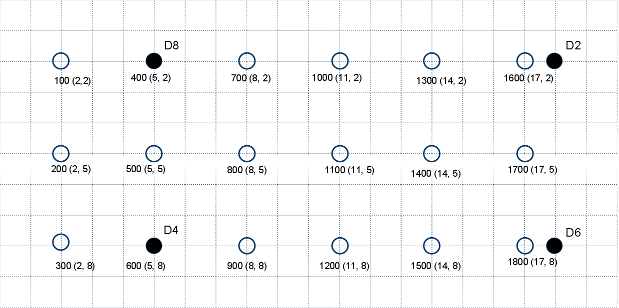

Figure : Layout of the tracking area – Smith Food Court, SMSU

The error of measurement at each locating point was recorded. The error is defined as the Euclidean distance between the actual location and calculated location. The measurements were conducted at exact calibration points, 0.5m, and 1m far away from the calibration points.

|  |  |  |  |  |  |
| --- | --- | --- | --- | --- | --- |
|  | **Location** | | **Error as distance (m)** | | |
| Block ID | X | Y | Exact | 1m | 0.5m |
| 100 | 2 | 2 | 0 | 0.5 | 2.5 |
| 200 | 2 | 5 | 0 | **confused** | 2.5 |
| 300 | 2 | 8 | **confused** | 3 | 4 |
| 400 | 5 | 2 | 0 | 2 | 0.5 |
| 500 | 5 | 5 | 0 | 2 | 2.5 |
| 600 | 5 | 8 | 0 | 2.5 | 0.5 |
| 700 | 8 | 2 | 0 | 2.2 | 2.5 |
| 800 | 8 | 5 | 0 | 2.5 | 1 |
| 900 | 8 | 8 | 0 | 4 | 3 |
| 1000 | 11 | 2 | 0 | 2.2 | 2.5 |
| 1100 | 11 | 5 | 3 | 3 | 3 |
| 1200 | 11 | 8 | 0 | 2 | **confused** |
| 1300 | 14 | 2 | 0 | 1 | 4 |
| 1400 | 14 | 5 | 2 | 5 | 3 |
| 1500 | 14 | 8 | 0 | 4 | 1 |
| 1600 | 17 | 2 | 0 | 2.2 | 3 |
| 1700 | 17 | 5 | 0 | 1.8 | 1.5 |
| 1800 | 17 | 8 | 0 | 1 | 0.5 |

Some measurements were noted as “confused” when the calculated location of the tag oscillated between two or more different locations on the map. These oscillations were caused by aliasing of the signal signature in the tracking area, where some locations have nearly the same signal signature.

## Final Results

Feasible experiments and acceptance tests were conducted to ensure our design meet the requirements. Technically, the designed TIU tracking system has satisfied basic requirements about size, power, and accuracy. We also conducted experiments with multi-tags and multi-detectors. In such testing, small adjustments of broadcast time interval and transmit window in firmware need to be done to reduce signal collisions. Otherwise, the system will corrupt since message packets will be dropped frequently and the controller will have lack of data to calculate out tags’ locations.

A fully testing with 10 detectors and 8 tags could not be done because of time and space constraint. It is hard to find a large area on campus where we can conduct such experiment. The typical dimension of the area we has had done experiments and testing is about 18m x 8m.

### Device dimensions

As shown the acceptance test for tags’ size, the physical dimensions of the final products are:

* Tag’s size: 1”x1”x1”
* Detector’s size: 3.5”x1”

The tag’s size satisfies the requirements given by the sponsors. There is no constraint about the size of detectors. With such small size, detectors are quite portable and can be mounted on ceiling of the tracking area.

### Power consumption

240mAh coin cell battery

30mA transmit current

40µA sleep current

1sec broadcast interval

3ms transmit window

0.3% duty cycle

### Accuracy

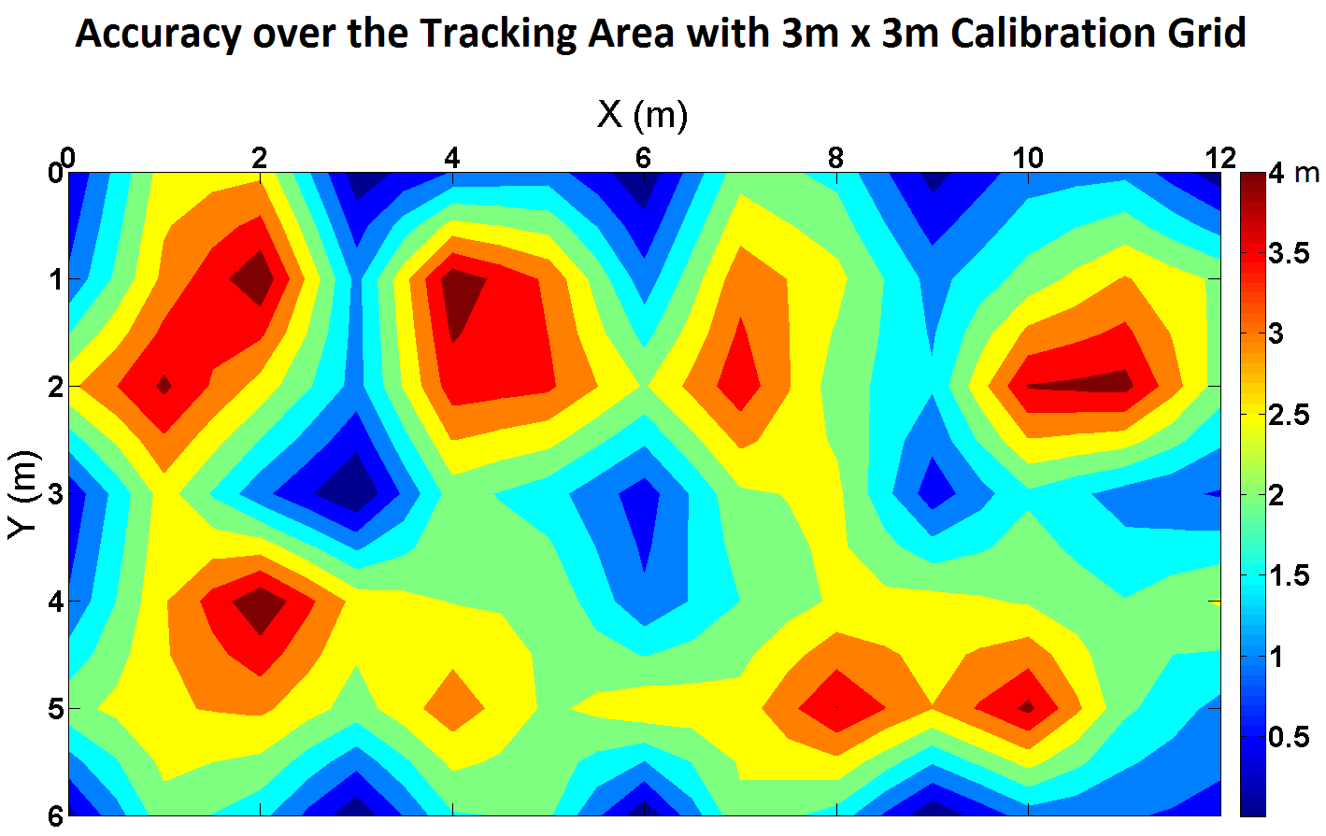

An accuracy map was plotted to show the error of locating results over the tracking area.

# Discussions

Antenna design

More testing

* Calibration density
* Detector placement

Improve testability

Different algorithms

Environment & signal strength

System configuration and detector installation

# Conclusions

We have a complete system that achieves small size, low cost, and battery life that exceeds 1 month. As for accuracy, when a tag is placed on exactly a location that was calibrated, success rates are at least 90%. The average accuracy, or error, over the tested tracking area is about two meters. Basically, we have achieved all requirements given by the sponsor: size, power, and accuracy. In fact, we specified a challenging accuracy which is 1.5m (5 ft.). However, we claim that such accuracy level is difficult to be achieved with limitation of radio technology as well as with prototypes in this capstone project.

There is also the trade-off between the system’s cost and performance. Obviously, tracking TIU in Intel’s validation lab requires high reliability rather than high accuracy since the system must tolerate to noise in lab environment while TIUs are pretty large PCBs that can be easily found within 5m.

Further work to be done includes refining the testability of the system, analyzing antenna radiation pattern, and improving the robustness of the location algorithms. The hardware design could be optimized further to improve the system’s performance and reliability.

## What we learned

This project presented many opportunities to expand our horizon. On a high level, we were responsible for bringing to fruition an entire system from a mere idea. This required requirement gathering, cost analysis, case studies, creativity, cooperation, experimentation, trials, and solid group communication. Every one of these brought with it a myriad of educational experiences and opportunities that we will be able to take with us as we go into the future. On a technical level, this project allowed us to bring together many different technologies under one roof. From microcontrollers, circuit layout, wireless communications, math, databases, and user experience. The variety of technologies gave us an opportunity to bring one component up at a time, and slowly integrate them into a single, seamless system. This level of engineering is a powerful capability to add to our resumes. Finally, our team had to overcome and compensate for a dynamic group environment. It required us to make sure our thoughts were crystal clear, and our words were concise. We learned how to civilly express ourselves when we felt constructive, and when we felt critical.

In this project, we also have experience in how to solder surface mount devices. It is actually easy than we thought at first. We were trained soldering techniques in pre-capstone course (ECE 411) and it is amazing that these practices are quite useful in capstone project.

## Good Decisions

Deciding to use Received Signal Strength Indication (RSSI) seems to be the right choice for an indoor locating system. We have had a lot of discussions about medium and methods using for the tracking system. We focused on radio frequency wave as the medium for detection and tracking and RSSI was selected as basis for calculating method. Within indoor environments, propagation loss model with triangulation methods is difficult to be implemented since reflection, attenuation, and multipath effect will strongly affect radio signal. A unique radiation pattern, or fingerprint, was assumed to be representative for a location, even though aliasing could not be eliminated out of noisy environments.

## Bad Decisions

## Meeting our Expectations

## Meeting our Sponsors Expectations

## Group Dynamics

Conflicts in group during the project were unavoidable. However, we always tried to resolve them in a constructive ways, which means to help the team moving forward. Actually, conflicts could be seen as positive factors that contribute to the success of the project since we had more discussions, arguments for right choices and selecting best ideas. That is also a valuable lesson for us since we might deal with similar situations in future when we work in companies.

# Appendices

## Installation

### Detector Deployment

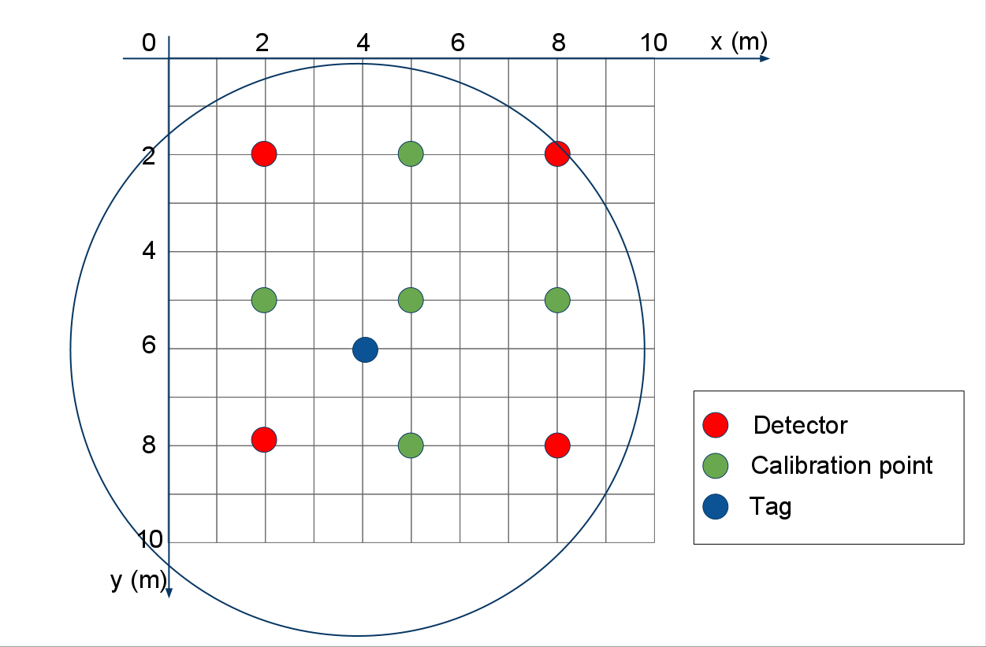

### Tag Deployment

### Controller Setup

(Daniel)

### Proxy Setup

(Daniel)

## Maintenance

### Replacing Batteries

(Tri) (Need Photo here)

### Programming Firmware

Both tags and detectors are designed to support programming. The devices’ firmware can be updated using 6-pin ISP header on printed circuit board. An easy way to reprogram the chip is using AVR Studio with ISP mkII Programmer. Refer to online tutorials from manufacturers for more information (also see **Useful Links** section).

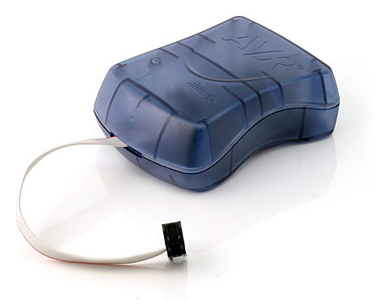

Figure : ISP mkII programmer (Atmel Corp.)

### Software Maintenance

### Source codes

All source codes are open and available on ***Project Hosting on Google Code*.**

URL: <http://code.google.com/p/tiu-tracking/>

## User Guide

### Web-based application

#### Users

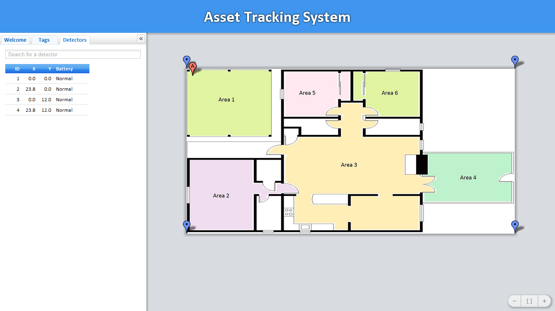

Figure : Web-based application user interface

Users can select/deselect on Options to display/hide tags and detectors on 2D map.

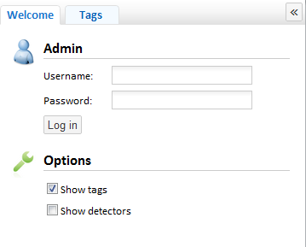

Figure : Options Table

**Display detectors’ info**

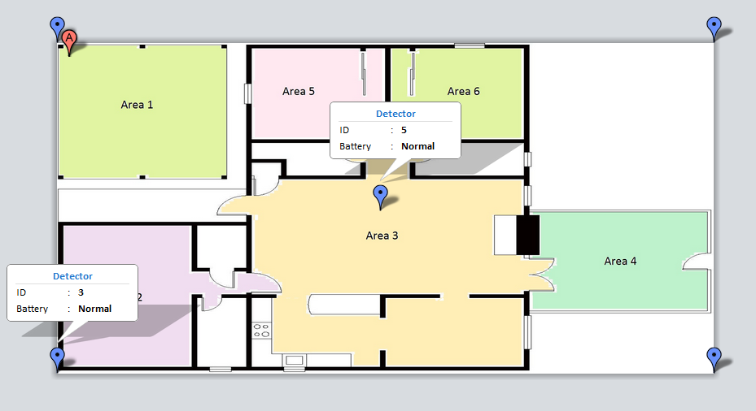

Figure : Display Detectors’ info on 2D map

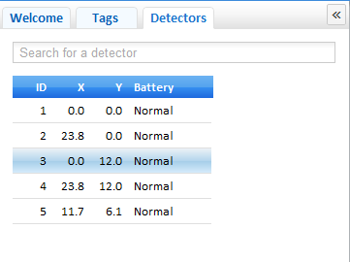

Figure : Detector’s info table

**Find an asset on the map**

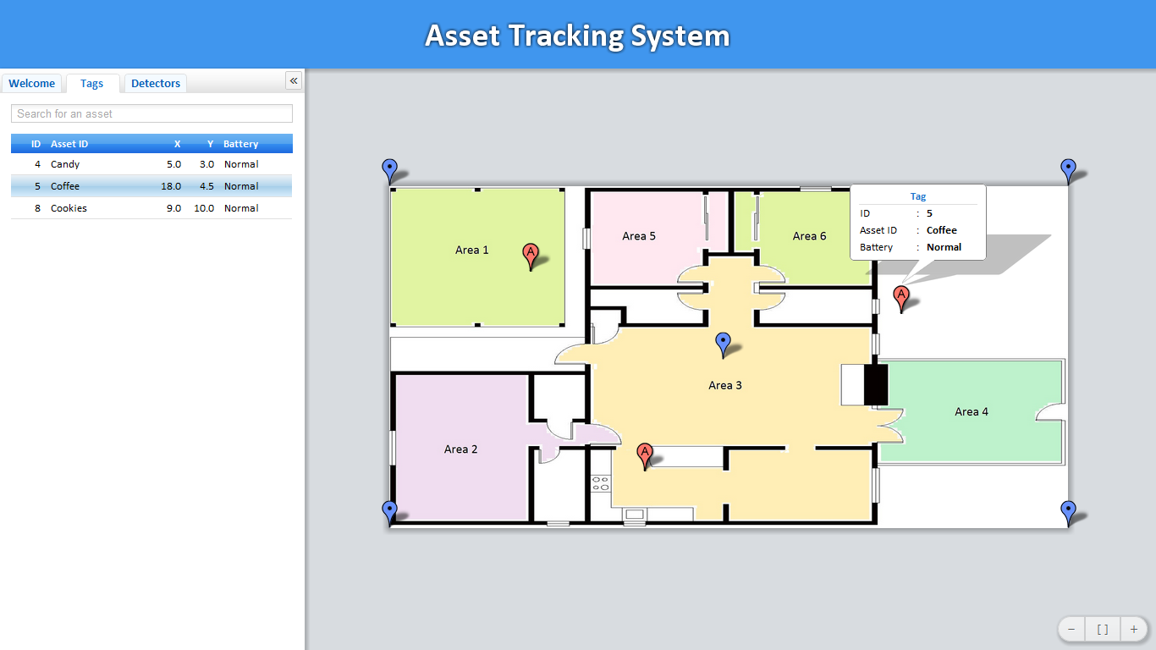

Figure : Show tag’s info on 2D map

Each asset (TIU) has a unique ID which is mapped to asset tag ID shown on the map of the Web app. To display a tag’s info, including ID, Asset ID, and battery status, either of the following ways are applicable:

* Click the read bubble on 2D map. Note that corresponding line on the table is highlighted.
* Move the mouse over the red bubble.
* Select an asset tag displayed on the table (left side).

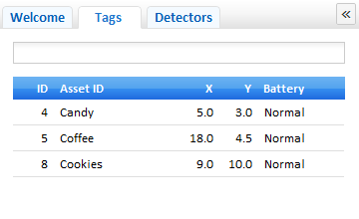

Figure : Tag’s info table

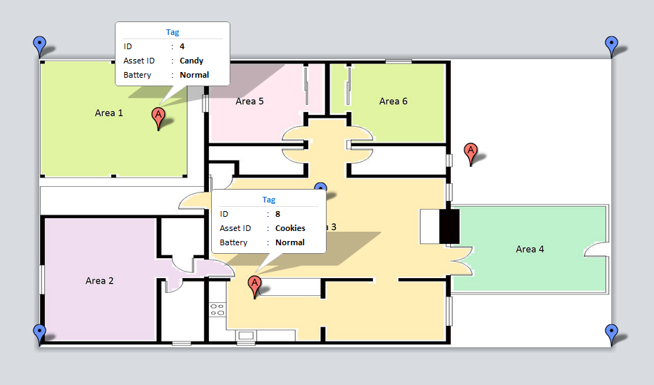

Figure : Multi-tags’ info are displayed on 2D map

To find an asset tag quickly, users can enter Asset ID into Search textbox. **Instant Filter** function returns matched results.

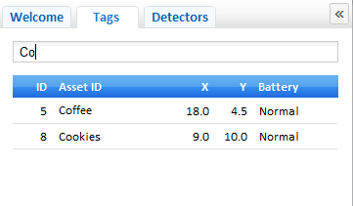

Figure : Search a tag with search textbox

**Zooming and Panning**

The web app highly supports zooming and panning functions. Users can experience by dragging mouse, rolling mouse wheel to zoom in and zoom out. Basic zooming functions are provided at the right bottom corner of the web app.

**Recommended Web browsers**

The Web-based application of the TIU Tracking system has deployed latest web technologies which are supported so well on current Web browsers such as Chrome, Mozilla Firefox, and Safari. We strongly recommend using Chrome for the highest performance of the application.

#### Administrator

**Log in session**

In order to have privilege to configure the system, users need to log in as administrator. In Admin mode, the administrator can:

* Add/Remove tags
* Add/Remove detectors
* Modify detectors’ locations
* Upload a new map
* Change password, add/modify authorized users who can log in

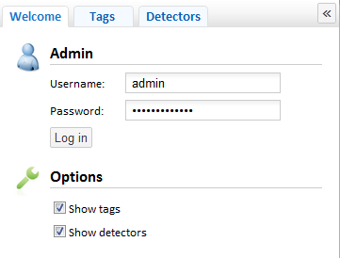

Figure : Log in session

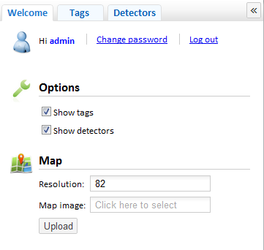

Figure : Admin control table

**Upload a new map**

In Admin mode, users can upload a new map for the tracking area.

* Click on **Map Image** box
* In **Open File** Dialog Box, select a new map (*.jpg, *.png, …)
* Specify an appropriate resolution in **Resolution** textbox
* Click **Upload**. Then, refresh Web browser to see the new map

**Add detectors in tracking area**

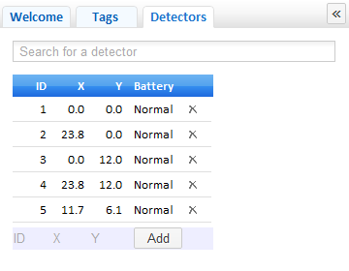

Figure : Add detectors to the system

To add a detector to the system,

* Enter ID and (X, Y) location of the detector. Detector’s location can be specified by clicking on 2D map.
* Click **Add** to finish the task
* Detectors’ info can be modified by add a new detector with the same ID.

### Controller application

The controller software application provides utilities to calibrate, locate tags, and diagnostics tools. In this guide section, we will show how to use the controller software properly.

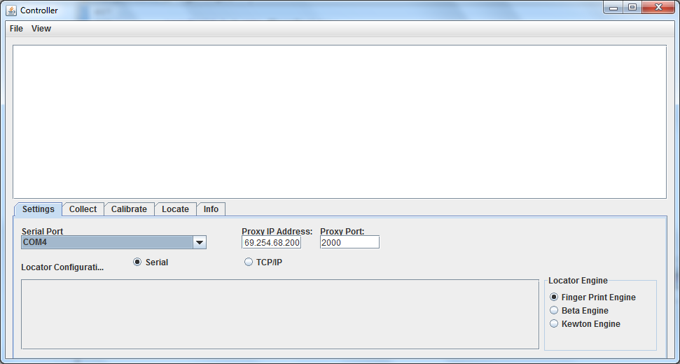

Figure : The controller application user interface

#### Set up connection between proxy and controller

**Wi-Fi Proxy connection**

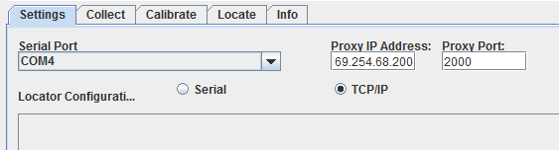

Figure : Wi-Fi Proxy Connection Settings

**Serial connection**

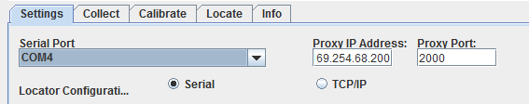

Figure : Serial Connection Settings

To run the controller using serial-connected Arduino board as a base,

* Plug the Arduino board to USB port on computer
* Run Controller Java application
* In Setting tab, select **Serial** radio button
* Select Serial Port (e.g. COM4)

#### Run Controller application

**Data Collecting Mode**

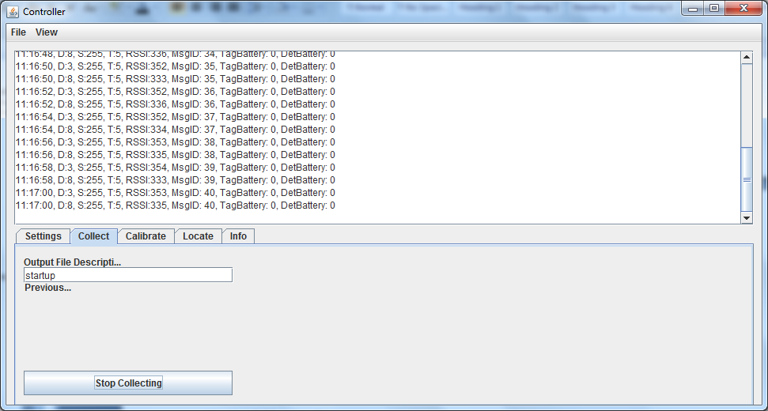

Figure : Controller runs in data collecting mode

**Calibrating Mode**

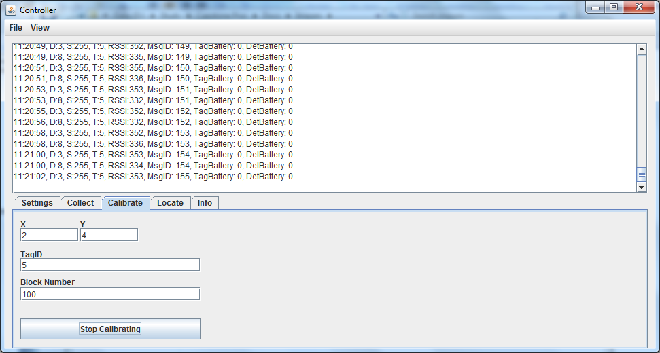

Figure : Controller runs in calibrating mode

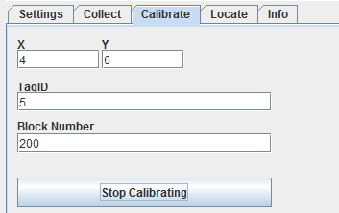

Figure : Parameters and Location Settings in one calibration

**Locating Mode**

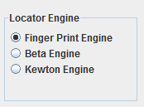

Figure : Choose Location Engine (Locating algorithm)

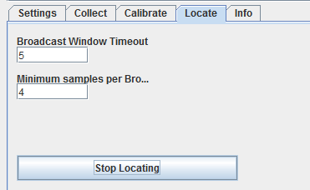

Figure : Locate tab settings

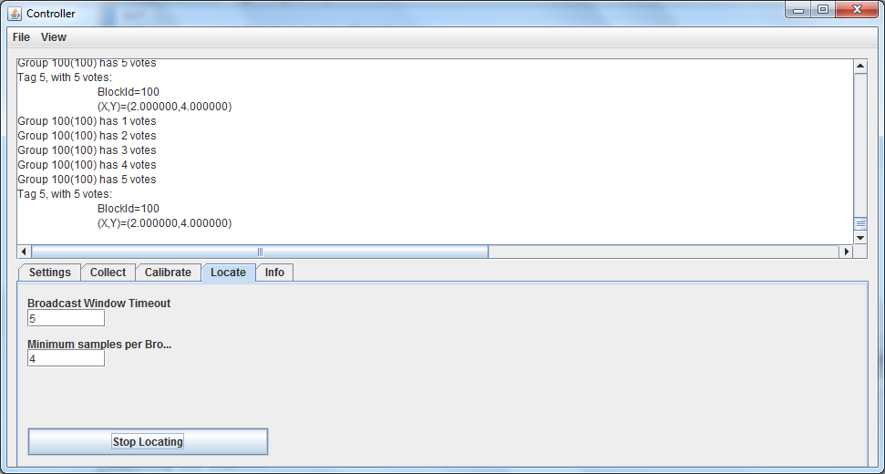

Figure : Controller run in Locating Mode

**Viewing Calibration Data**

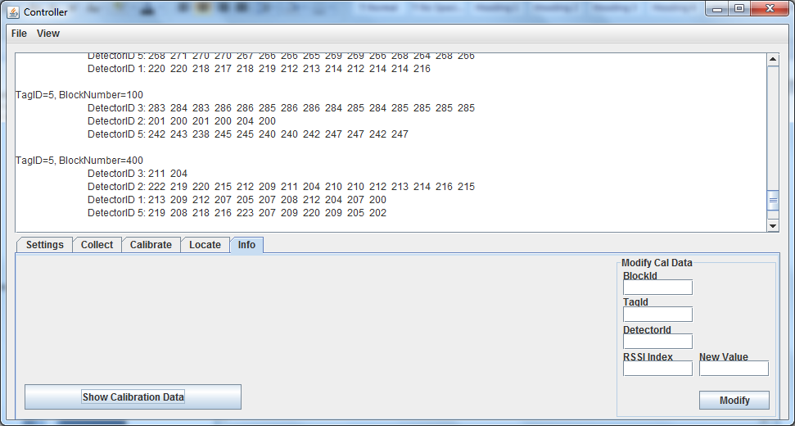

Figure :View calibration data file

## Hardware Design Specification

The infrastructure of the tracking system consists of detectors, asset tags, proxies and a server, as shown in below figure.

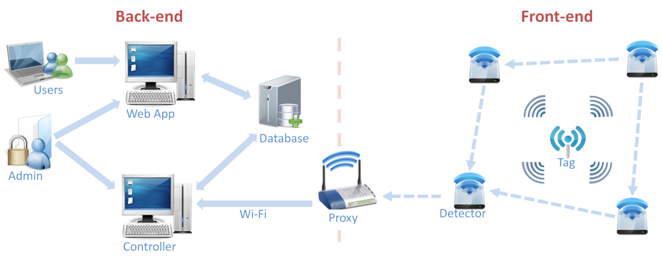

Figure : TIU Tracking System topology

The following sections provide more details about hardware design in the front-end network. These sections will help readers reproducing the PCB products effectively. All design specifications and schematics are delivered.

### Detectors

A detector consists of two major parts: a microcontroller, and a RF transceiver. The microcontroller controls the RF transceiver. The RF transceiver is responsible for communicating information to the system.

#### Functionality

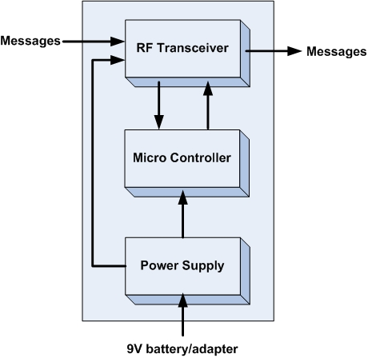

|  |  |
| --- | --- |
| Module | Detectors |
| Inputs | * Power supply: 3.3V DC * Messages from asset tags and other detectors |
| Outputs | * Messages from asset tags and other detectors |
| Functionality | A detector consists of two major parts: a microcontroller, and a RF transceiver. The microcontroller controls the RF transceiver. The RF transceiver is responsible for communicating information to the system. |

#### What is on the board?

* A power switch on/off
* A 3.3V power regulator which can sustain maximum 16V input voltage.
* An ATMega328p MCU by Atmel with 8MHz
* A 6pins SPI connector for programming.
* A RFM12B wireless RF module for 434MHz ISM band by Hope RF.
* A LED with jumper (on/off) for checking power.
* A LED with jumper (on/off) for checking signal transmission.

#### Advantages

* By including a 3.3V regulator, the detector can be powered a DC power adapter, or various types of 3.6 - 16V batteries.
* The RFM12B module is a low cost option with sufficient power and range to provide reliable communication around the lab - a basic packet protocol can be implemented in just 2..3 Kb of C code.
* Had 2 LEDs for debugging power and signal transmission.
* Small size 1” x 3.5”.
* There are many possible microcontrollers we could use to implement a solution. The ATMega328p is a good choice because they are supported in Arduino platform.
* RF12B transceiver is a good choice because of low price, good support and low power consumption.

#### Schematic



Figure : Schematics of a detector

#### Board Layout

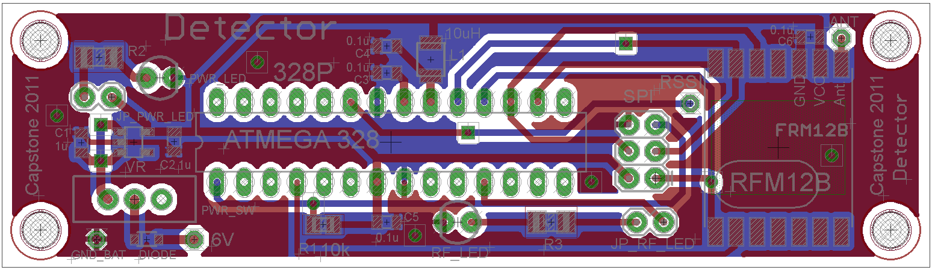

Figure : Two-layer PCB layout of a detector with shown ground plane

#### Real Board

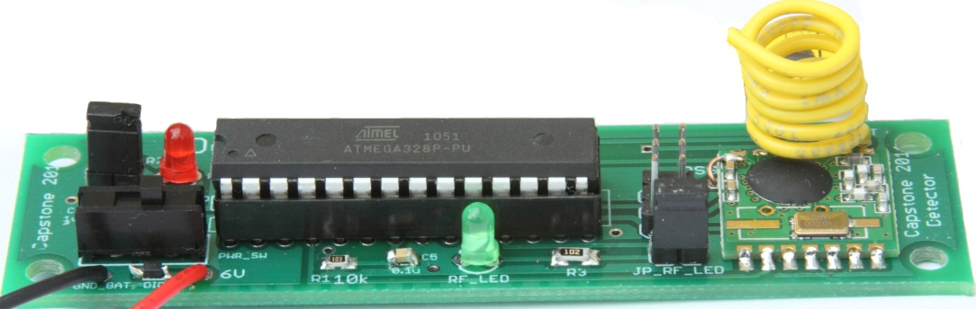

Figure : PCB prototype of a detector

#### Port/Pin Mapping

**ATMega328P – 28 pins**

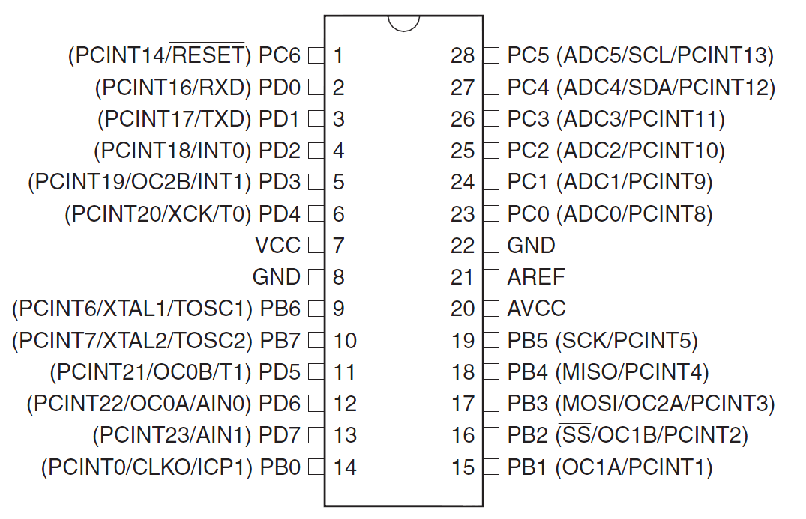

**SPI connector**

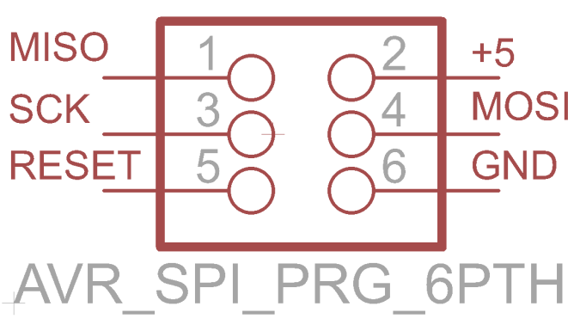

|  |  |  |
| --- | --- | --- |
| Pin | Name | Description |
| 1 | MISO | master in / slave out |
| 2 | +5V | Regulated +5V |
| 3 | SCK | SPI clock |
| 4 | MOSI | master out / slave in |
| 5 | RESET | Reset |
| 6 | GND | ground |

**RFM12B**



|  |  |  |
| --- | --- | --- |
| Pin | Name | Description |
| 1 | SDO | Serial data output |
| 2 | nIRQ | Interrupts request output |
| 3 | FSK/DATA/nFFS | Transmit FSK data input/Received data output/FIFO select |
| 4 | DCLK/CFIL/FFIT | Clock output/Extrenal filter capacitor/FIFO interrupts |
| 5 | CLK | Clock output for external microcontroller |
| 6 | nRES | Reset output |
| 7 | GND | Ground |
| 8 | ANT | Antenna |
| 9 | VDD | VCC |
| 10 | GND | Ground |
| 11 | nINT/VDI | Interrupt input |
| 12 | SDI | SPI data input |
| 13 | SCK | SPI clock input |
| 14 | nSEL | Chip select |

#### Part list

|  |  |  |
| --- | --- | --- |
| Part | Value | Details |
| ATMega328 | Atmel's ATMega328 | Atmel's ATMega328 8-Bit Processor in 28 pin DIP |
| RFN12B | RFM12B-S2 | RFM12B-S2 Wireless Transceiver |
| Socket IC | Socket for ATMega328p | Socket IC open frame 28Pos 0.3” |
| SPI | SPI 6 pins connector | 6 POS connector header |
| PWR_SW | Power switch | SPDT Mini Power Switch |
| VR | Voltage regulator 3.3V | IC VREG LDO 3.3V |
| DIODE | Diode | DIODE SBR 1A 30V SOD-323 |
| C1, C1 | 1uF | CAP CERM 1UF 25V Y5V 0805 |
| C3, C4, C5, C6 | 0.4uF | CAP CERM .10UF 50V 5% 0805 SMD |
| L1 | 10uH | INDUCTOR 10UH 10% SA TYPE SMD |
| R1 | 10K | RES 10K OHM 1/4W 5% 0805 SMD |
| PWR_LED | Power LED 3mm | Power LED 3mm |
| RF_LED | LED 3mm | LED for signal transmission |
| JP_RF_LED | 2 pins male header | 2 pins male header |
| JP_PWR_LED | 2 pins male header | 2 pins male header |

### Asset Tags

An asset tag consists of two major parts: a microcontroller, and a RF transceiver. The microcontroller controls the RF transceiver. The RF transceiver is responsible for communicating information to the system.

#### Functionality

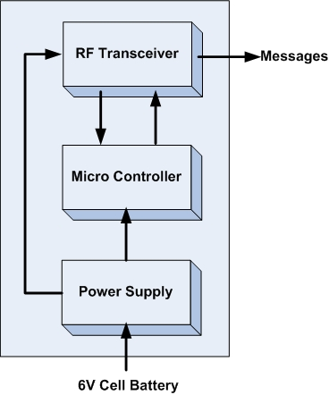

|  |  |
| --- | --- |
| Module | Asset Tags |
| Inputs | Power supply: 3.3V DC |
| Outputs | Messages containing tag’s ID |
| Functionality | An asset tag consists of two major parts: a microcontroller, and a RF transceiver. The microcontroller controls the RF transceiver. The RF transceiver is responsible for communicating information to the system. |

#### What is on the board?

* A power switch on/off
* A 3.3V power regulator which accepts 2.2V to 6V as external power source.
* An ATMega328p MCU by Atmel with 8MHz
* A 6pins SPI connector for programming.
* A RFM12B wireless RF module for 434MHz ISM band by Hope RF.
* A jumper which connect to DP3 pin of ATMega328p for debug/mode.
* 2x7pins headers female for connecting with RFM12B breakout board.

#### Advantages

* Designed from the ground up to support very low-power use with batteries.
* The RFM12B module is a low cost option with sufficient power and range to provide reliable communication around the lab - a basic packet protocol can be implemented in just 2..3 Kb of C code.
* Very small size 1” x 1”
* Very low power consumption
* There are many possible microcontrollers we could use to implement a solution. The ATmega 328p surface mount packet is a good choice because they are the Arduino technology platform and very small size.
* FR12B transceiver is a good choice because of low price, good support and low power consumption

#### Battery life

#### Schematic



Figure : Schematics of a tag

#### Board Layout

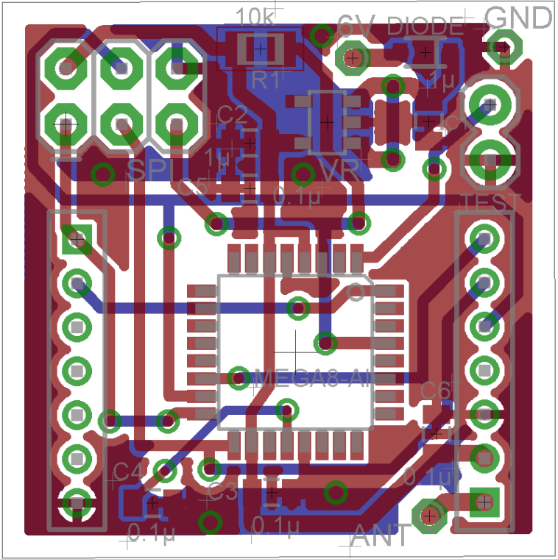

Figure : Two-layer PCB layout of a tag with shown ground plane

#### Real board

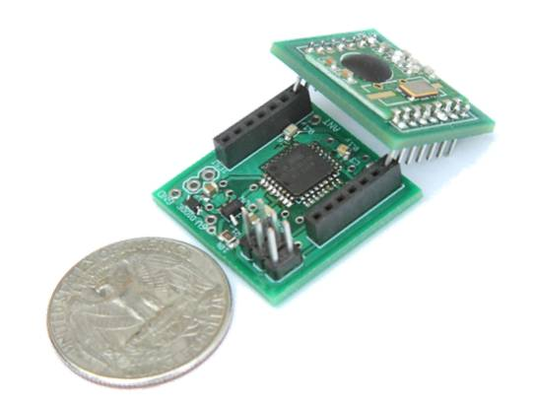

Figure : Asset Tag: main board with MCU and breakout board with RF chip

#### Port/Pin Mapping

**ATMega328P – 32 pins**

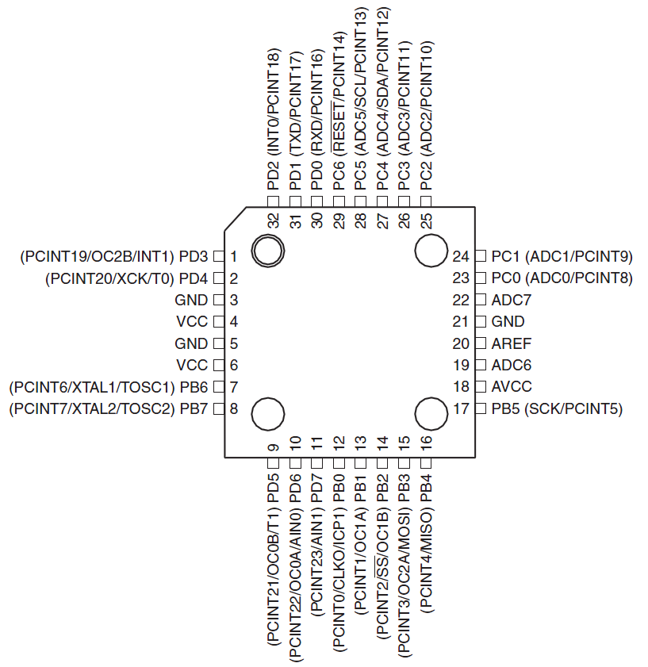

Figure : ATMega328P 32TQFP pin-out (top view)

#### Part list

|  |  |  |
| --- | --- | --- |
| Part | Value | Details |
| ATMega328 | IC MCU AVR 32K FLASH 32TQFP | IC MCU AVR 32K FLASH 32TQFP |
| SPI | SPI 6 pins connector | 6 POS connector header |
| VR | Voltage regulator 3.3V | IC VREG LDO 3.3V |
| DIODE | Diode | DIODE SBR 1A 30V SOD-323 |
| C1, C1 | 1uF | CAP CERM 1UF 25V Y5V 0805 |
| C3, C4, C5, C6 | 0.4uF | CAP CERM .10UF 50V 5% 0805 SMD |
| R1 | 10K | RES 10K OHM 1/4W 5% 0805 SMD |
| LEFT | 2mm 7-pin Socket | 2mm 7-pin Socket |
| RIGHT | 2mm 7-pin Socket | 2mm 7-pin Socket |
| TEST | 2-pins header | 2-pins header |
| Battery | Coin Cell battery 20mm 240mAh | Coin Cell battery 20mm 240mAh |

### RFM12B Breakout board

#### What is on the board?

* A RFM12B wireless RF module for 434MHz ISM band by Hope RF.
* An copper straight-wire antenna.

#### Advantages

* The breakout board for the RFM12B which gives you access to the pins.
* Easy to solder. And implement.
* Had an antenna on it.
* Very small size 0.8” x 0.9”

#### Schematic



Figure : Schematics of a breakout board

#### Board Layout

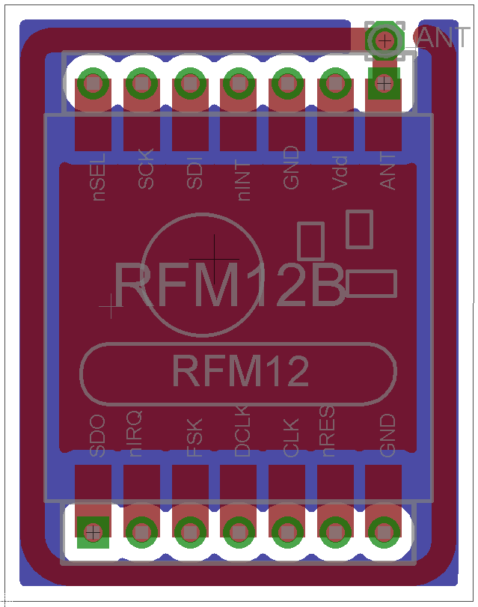

Figure : PCB layout of a breakout board with shown ground plane

#### Real Board

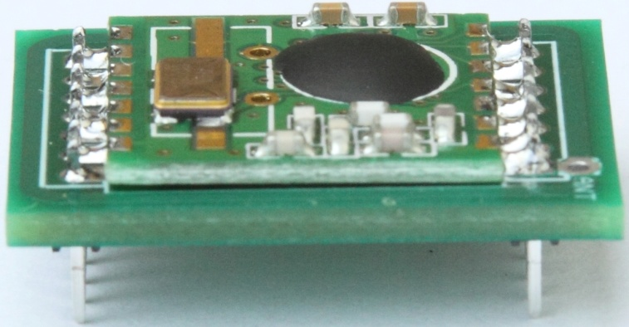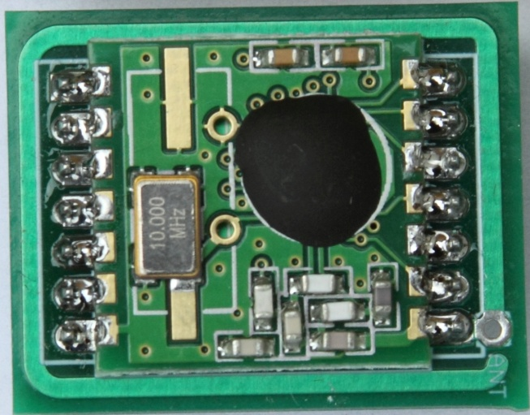

#### Part List

|  |  |  |
| --- | --- | --- |
| Part | Value | Details |
| RFN12B | RFM12B-S2 | RFM12B-S2 Wireless Transceiver |
| LEFT | 2mm 7-pin male header | 2mm 7-pin male header |
| RIGHT | 2mm 7-pin male header | 2mm 7-pin male header |

## Software Design Specification

## Useful Links

TIU Tracking System Demo: <http://www.youtube.com/watch?v=sZbXoZNrWNc>

Web app Demo: <http://www.youtube.com/watch?v=XX9sif2QWpw&feature=related>

ISP mkII Programmer User Guide: <http://www.atmel.com/dyn/resources/prod_documents/AVRISPmkII_UG.pdf>

# References